**Phase 5: Innovation-Transforming theTraffic**

**Management**

**Project Objectives:**

The primary objectives of this project are:

1. To provide real-time traffic information to commuters.
2. To help commuters make optimal route decisions.
3. To improve traffic flow by diverting vehicles from congested areas.

**IoT Sensor Setup:**

For the IoT sensor setup, you will need various sensors such as:

* Traffic cameras for visual data.
* Traffic flow sensors (inductive loops or ultrasonic sensors) for vehicle count and speed.
* Weather sensors (temperature, humidity, precipitation) for weather-related traffic impact.
* GPS devices on public transport or service vehicles for location tracking.

**Mobile App Development:**

The mobile app will be developed for iOS and Android platforms. It should include features like:

* Real-time traffic data display, including congestion levels.
* Route suggestions based on current traffic conditions.
* Alerts for accidents, road closures, or adverse weather.
* Integration with the Raspberry Pi for data retrieval.
* User customization for favorite routes and destinations.
* Integration with GPS for real-time location-based data.

**Raspberry Pi Integration:**

Raspberry Pi can serve as the central hub for data collection, processing, and distribution. The setup can include:

* A Raspberry Pi connected to IoT sensors via USB or Wi-Fi.
* Data processing and analysis using Python or another suitable language.
* Data storage and management (e.g., a database to store historical data).
* Integration with the mobile app through APIs or web services.

**Code Implementation:**

The code can be divided into three main components:

**Data Collection and Processing:** Collect data from IoT sensors, process it to derive useful information (e.g., traffic flow, congestion levels, and weather conditions), and store it in a database.

**Mobile App Development:** Develop the mobile app using a suitable framework (e.g., React Native or Flutter). Implement features for real-time data retrieval, route suggestions, and user interaction.

**Raspberry Pi Code:** Develop code for the Raspberry Pi to fetch data from sensors, analyze it, and provide data to the mobile app. The code should also include logic for sending alerts and updates to the app.

**Diagrams and Screenshots:**

**System Architecture Diagram:**

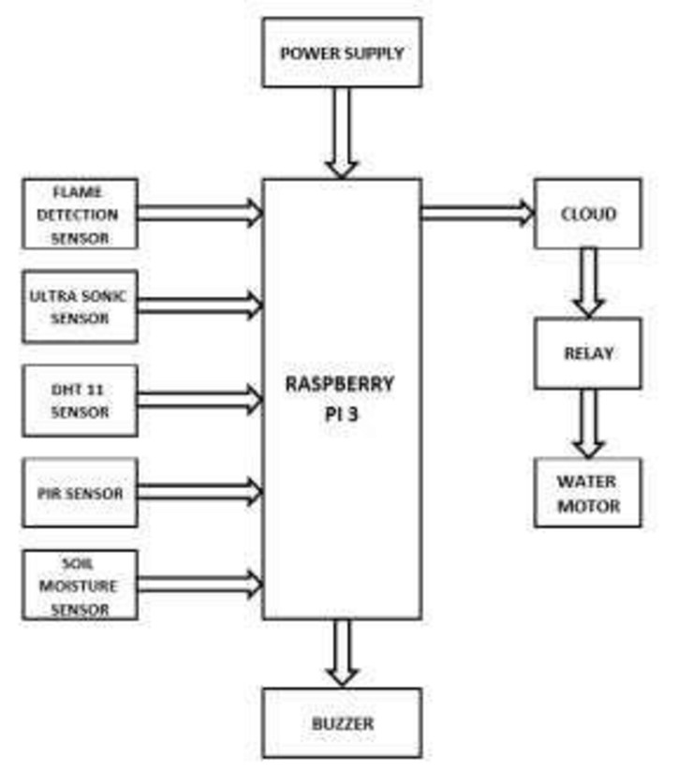

**IoT Sensor Setup Schematic:**

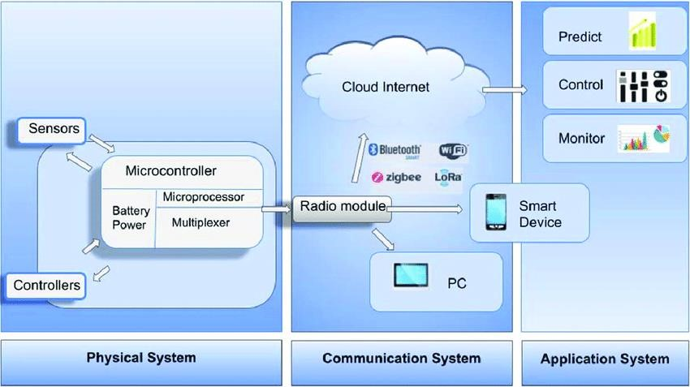

**Mobile App Screenshots:**

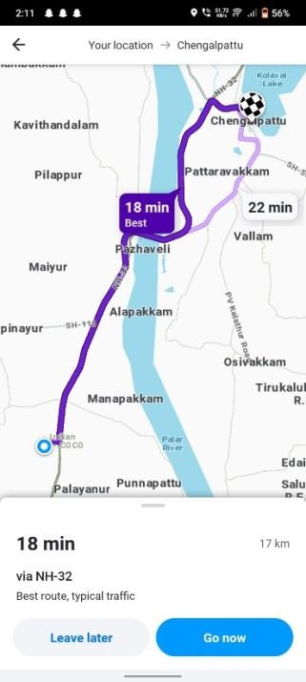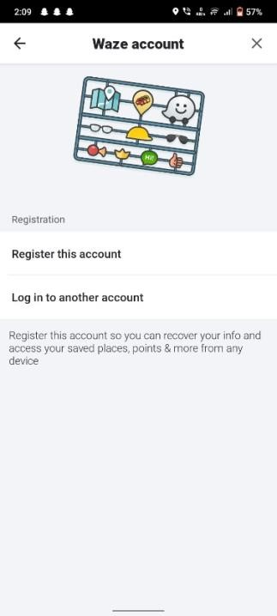

**Benefits for Commuters:**

The real-time traffic monitoring system can assist commuters in the following ways:

**Optimal Route Decisions:** Commuters can make informed decisions about the best routes to their destinations based on real-time traffic data, reducing travel time and frustration.

**Avoiding Congestion:** By diverting vehicles away from congested areas, the system can help decongest traffic, leading to smoother traffic flow and reduced commute times.

**Accident and Weather Alerts:** Commuters will receive immediate alerts about accidents, road closures, and adverse weather conditions, enabling them to adapt their routes and schedules accordingly.

**Public Transport Integration:** Integration with GPS on public transport allows users to track the real-time location of buses or trains, helping them plan their journeys more effectively.

**Historical Data Analysis:** The system can provide historical traffic data, which can be used for urban planning and traffic management improvements.